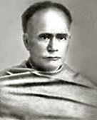
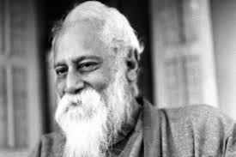
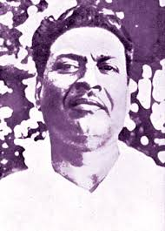

[Affialiated by the University of Burdwan]

MITA ROY
Assistant Professor of Bengali
GUSHKARA MAHAVIDYALAYA

Bivutibhusan Bandyopadhyay Rabindranath Tagore Iswar Chandra Vidyasagar
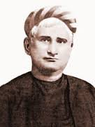
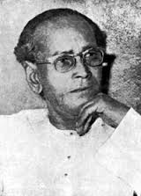

Tarashankar Bandyopadhyay Bankim Chandra Chattopadhyay
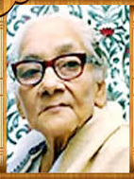
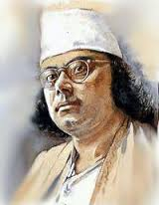

PERSONAL POFILE

Kazi Nazrul Islam Ashapurna Devi

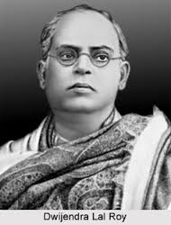
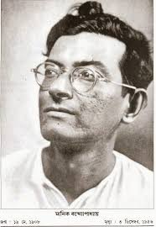

Manik Bandyopadhyay Dwijendralal Roy
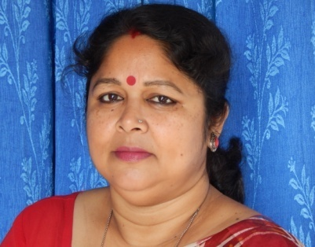
Personal Profile
- Name : MITA ROY
- Department : Department of Bengali
- Designation : Assistant Professor
- Date of Birth : 03.11.1973
- Residential Address with
Mobile Number : Vill. & P.O. Nahata, Dist. North 24 Parganas
West Bengal, India
Mob: 8902715011. E-mail: srishtikatha@gmail.com
- Date of joining in the college : 25.04.2005
- Period of service in other
College/Institution (if any) : 4 Yrs. 10 Mths. (Part-time) in Nahata J.N.M.S.
Mahavidyalaya, North 24 Parganas, W.B.
- Total teaching experience
- UG (General) : 11+ Years
- UG (Honours) : 11+ Years
- PG : NA
- Others : NA
- (i) Academics:
Exam. | Board/Univ. | Year of Passing | Div./Class | % of marks
Madhyamik | WBBSE | 1990 | 1st Div. | 61.66
HS | WBCHSE | 1992 | 2nd Div. | 52.1
BA  (Hons. in Bengali) | Rabindra Bharati University | 1995 | 2nd Class | 50.62
MA  (in Bengali) | Rabindra Bharati University | 1997 | 2nd Class | 55.1
B Ed | Calcutta University | 1999 | 2nd Class | 57.21
NET/SLET | UGC | 2001 | Qualified | -
M Phil | Rabindra Bharati University | 2002 | A Grade | 65.25

(ii) Field of specialization : Mediaeval Literature
(iii) For Ph.D./M.Phil. Degree holder : M. Phil
Contd…..P/2
Page -2

- Present research activities/
research experience and future
plan of research (if any) : Ph.D. Thesis submitted on 11.07.2016.

- Research guidance offered : Nil
[Give name(s) of the student(s)
and University concerned]

- Research Project carried out by the faculty : Ongoing
- Title of the Project : বনগাঁ মহকুমার প্রাচীন মেলাঃ গ্রামজীবনের চালচিত্র
- Name of the Funding Agency : UGC
- Duration : 2 years
- Remarks :

- Academic Award/Fellowships received : NA

- List of the Publications and /or authorship of Books : Annexure – I

- Seminar/Symposium/Conference/Workshops attended (Last five years):
Sl. No. | Date(s) | Place | Institution | Name / Title of the Conference
1 | 08.09.2011 | Burdwan | MUC Womens’ College | Rabindra Parabarti Bangla Kabitar Palabadal - National
2 | 31.01.2013 | Burdwan | MUC Womens’ College | Bange Hindu – Mussalman Samparker Itihas
3 | 19th & 20th Nov, 2013 | Magra Hooghly | Sri Gopal Banerjee College | Vivekananda on the 150th Birth Anniversary – National
4 | 12th & 13th Feb, 2014 | Raniganj | Raniganj Girls’ College | Bahurupe Sammukhe Tumi : Vivekananda – National
5 | 04.08.2014 | Kalyani | Kalyani University | Tarashankar Tiban O Kriti – National
6 | 19th & 20th Sept, 2014 | Mallarpur | Turku Hansda Lapsa Hemram Mahavidyalaya | Socio-Economic Environment of the Tribes of India with special reference to the Santals - National

Contd….P/3
Page – 3
Sl. No. | Date(s) | Place | Institution | Name / Title of the Conference
7 | 16th & 17th March, 2015 | Sriniketan | Visva-Bharati University | Women Empowerment : Challenges and Strategies – National
8 | 27th & 28th Mar, 2015 | Khujutipara | Chandidas Mahavidyalaya | Development of Politics in India
9 | 3rd & 4th Sept., 2015 | Rampurhat | Rampurhat College | Evolution of Bengal in 20th Century in the content of Liberal Arts and popular cultural – National
10 | 2nd & 3rd Dec., 2015 | Bolpur | Bolpur College | Rabindranath tagore : Humanity & Cultural Affinity – National
11 | 8th Dec, 2015 | Shyamsundar | Shyamsundar College | Women in the 20th Century Bengali Literature – Special Seminar
12 | 22nd Feb, 2016 | Gushkara | Gushkara Mahavidyalaya | Amar Bhabna amar Bhashay - Local
13 | 21st Mar., 2016 | Gushkara | Gushkara Mahavidyalaya | Women Empowerment : Swayambhar Gosthi
14 | 22nd Mar.,2016 | Gushkara | Gushkara Mahavidyalaya | Sap Bishyak Alochona
15 | 6th Sep., 2016 | Gushkara | Gushkara Mahavidyalaya | National Integration
16 | 7th Sep.,2016 | Gushkara | Gushkara Mahavidyalaya | Women Empowerment in Indian milestone and challenges

No. | Session | Period | Place / Institution
1. | 2011-2012 | 21st November to 12th Dec., 2011 | UGC Academic Staff College, Jadavpur University
2. | 2013-2014 | 18th March to 22nd March, 2014 | The Asiatic Society (Participated & presented the paper ‘Bangla Sahitye Krishna Mith’
3. | 2014-2015 | 4th Feb to 24th Feb, 2015 | 2nd Refresher course, UGC Academic Staff College, Burdwan University
4. | 2015-2016 | 28th January, 2016 | One day workshop organized by Bolpur College entitled ‘Vishakha Act awareness programme’
5. | 2015-2016 | 23-29th June, 2016 | HRDC, BU, ‘National Foundation for Communal Harmony’
- Orientation Programmes/Refresher Course attended (Last five years) :

Contd….P/4
Page – 4

- Member of Learned/Educational societies :
- Life Member of Bangiya Sahitya Parishad
- Life Member of Sahitya Academy
- Life Member of National Library
- Life Member of Jaykrishna Library, Uttarpara

- Synopsis of the Topic/Field of the subject taught by the Teacher
- Rabindra Sahitya
- Mediaeval Literature
- Fictions
- Types of Literature
- Novel
- Drama

For details see Syllabus Distribution in Annexure – II

- Extension activity (which may include activity in any academic and/or social associations/ society/public body/club/mission etc.
- Member, NCC Sub-Committee
- Member, Hostel Sub-Committee, Gushkara Mahavidyalaya
- Acted as Judge in various cultural events conducted by the College and NGOs
- Expert SSC, Eastern Zone
- Chairman, Gushkara Mahavidyalaya Employees Co-operative Credit Society Ltd.
- Convener of Seminar Sub-Committee, Gushkara Mahavidyalaya
- Convener of Anti Ragging Cell, Gushkara Mahavidyalaya
- Convener of Grievance Redressal Cell of Gushkara Mahavidyalaya
- Member of Cultural and Routine Sub-Committee, Gushkara Mahavidyalaya
- Superintendent of Nivedita Chhatrinibas, Gushkara Mahavidyalaya
- Member of the Governing Body of Katwa College, Katwa, Burdwan
- Life time Club Member, Binapani Sangha, Nahata, Nadia

- Any other presentable information about the faculty : NA

